Third Party Verification Shipping Form

Third Party Company Information
Name: | Shipping Address:
Phone: | Billing Address:
Contact Personnel: | Email:
Tax Identification Number: | Date:

UA Shipper Information
Name: |  | Shipping Address:
PI Name: |  | Billing Address:
Contact Personnel: |  | Email:
Phone: |  | Post-doc/grad/undergrad/lab personnel
UA Building: |  | UA Research Room Number:
Tax Identification Number: | Date: |  | CWID:

Chemical/ Shipping Material Information
Chemical Name:
Chemical Manufacturer:
State: Liquid / Gas / Solid / Powder
Quantity:
Shipping with any hazardous materials for preservation such as dry ice: if yes, please explain below:

Mark All Hazardous Classifications that Apply:

List All Precautionary Statements that Apply:

List All Hazard Statements that Apply:

Please complete the NFPA Fire Diamond for the Chemical you wish to ship:

Mark all DOT Shipping Labels that apply:

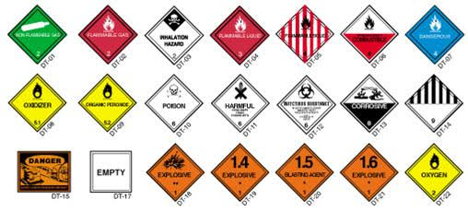

EHS Personnel Only
Verification: APPROVED DENIED
EHS Special Instructions:

EHS Personnel Print:
EHS Personnel Signature:
COI Third Party Shipment Number

